**Hungry Hungry Caterpillar Browser Game**

Vincent Emery III, James Searer, Asani Bellamy

Department of Computer Science, Indiana University of Pennsylvania

COSC 365: Web Architecture & Application Development

Dr. Terrence Fries

May 3rd, 2023

**Description**

For our project we decided to recreate the classic computer game “Snake” as a browser game with our own theme. Our theme is a caterpillar who eats fruit. For each fruit you eat, the caterpillar grows in length. The objective is to eat as many fruits as you can without either running into yourself or running the caterpillar out of bounds.

We used the MVC design architecture to create our project. We used HTML as the model for the web page, CSS as the view and styling for the web page and we used JavaScript as the controller. We used JavaScript to create our game through breaking different methods up into functions. We have functions such as update() that contains code that deals with movement, checking to see if you have eaten a fruit, and checking to make sure you have not triggered a loss condition. We used event listeners for the arrow keys to control the movement of the caterpillar in this function. A startGame() function gets the game ready for play by putting a fruit randomly on the play area, spawning the caterpillar with the starting size, and setting the current score to 0. When you lose the game the endGame() function is called that throws an alert stating that the game has ended and calls startGame() to reset the game board. We used context.FillStyle function to draw the play area. Hope you enjoy our game!

**Screenshots**

**Start of Game**

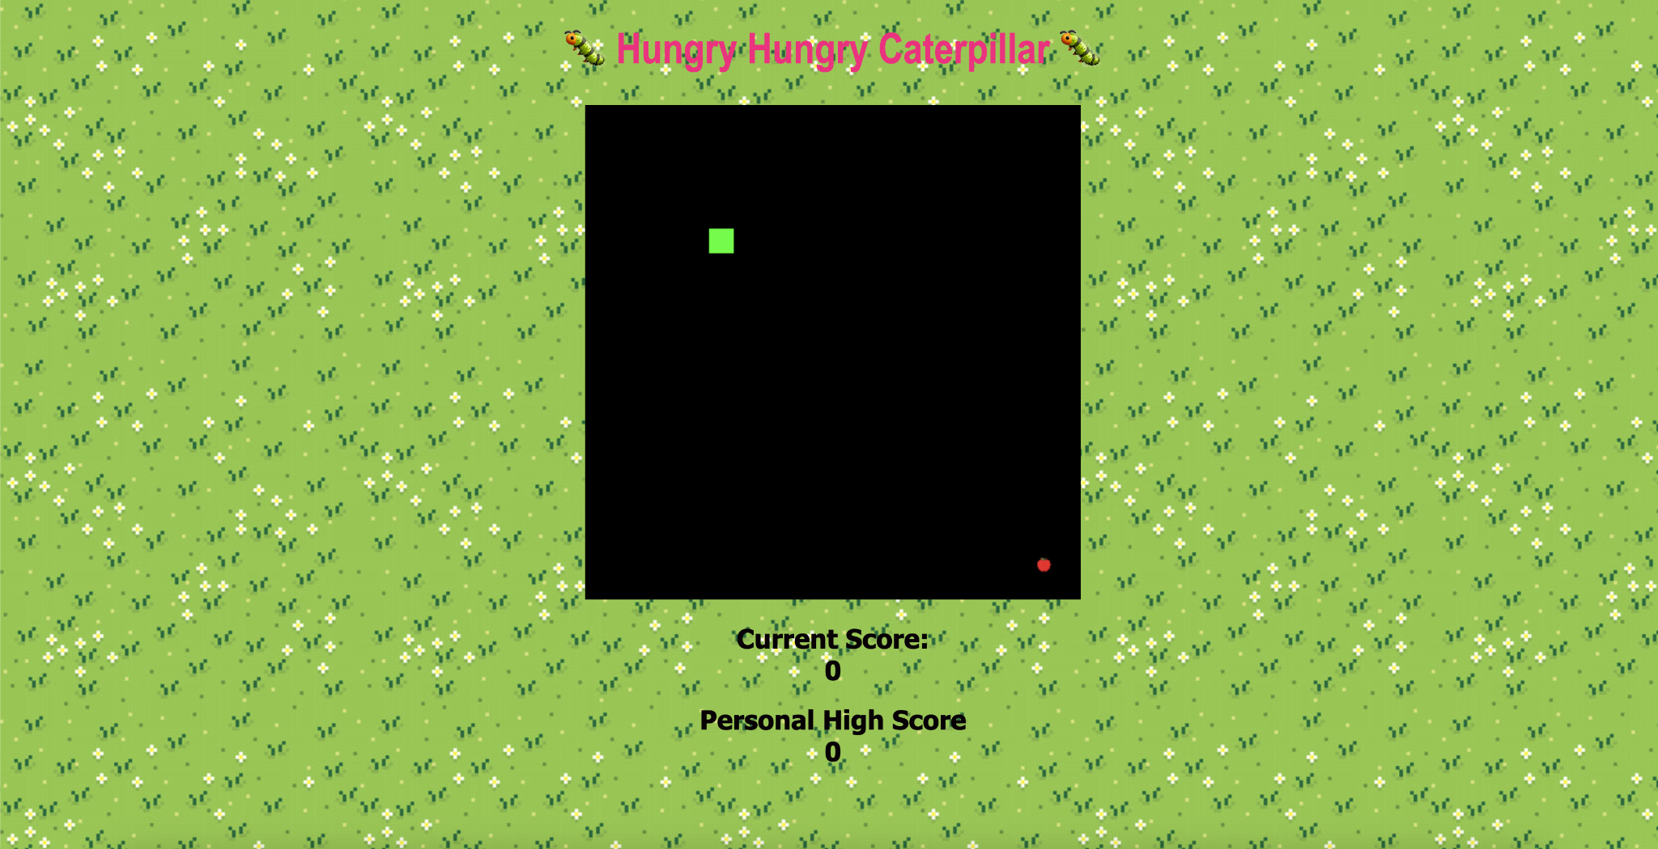

**During Play shows current score goes up as you eat fruit**

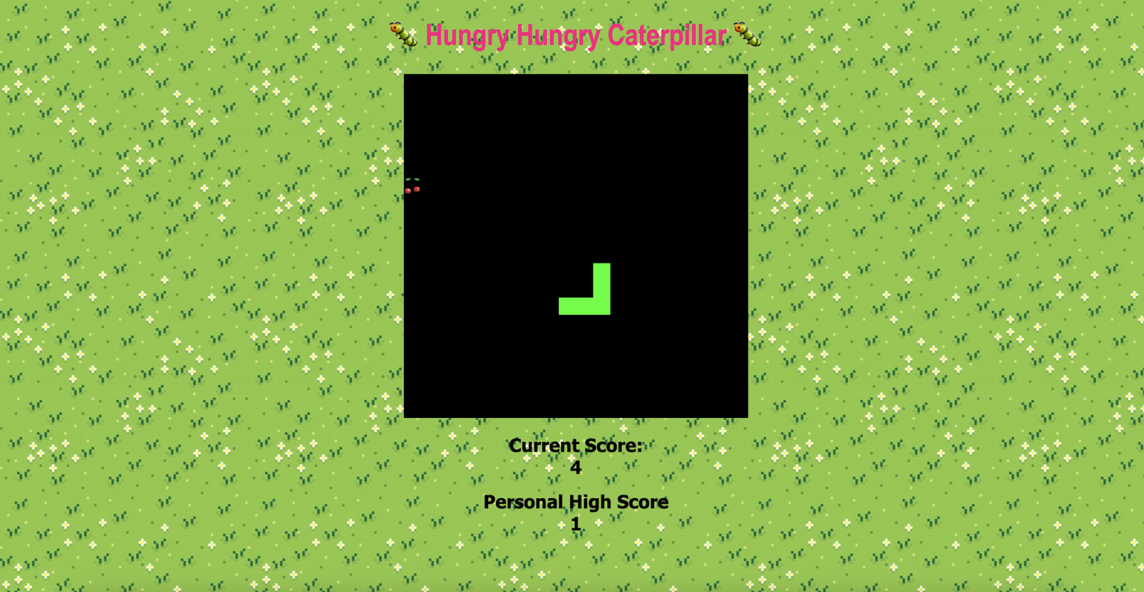

**High score is updated after you lose a game where you current score is higher**

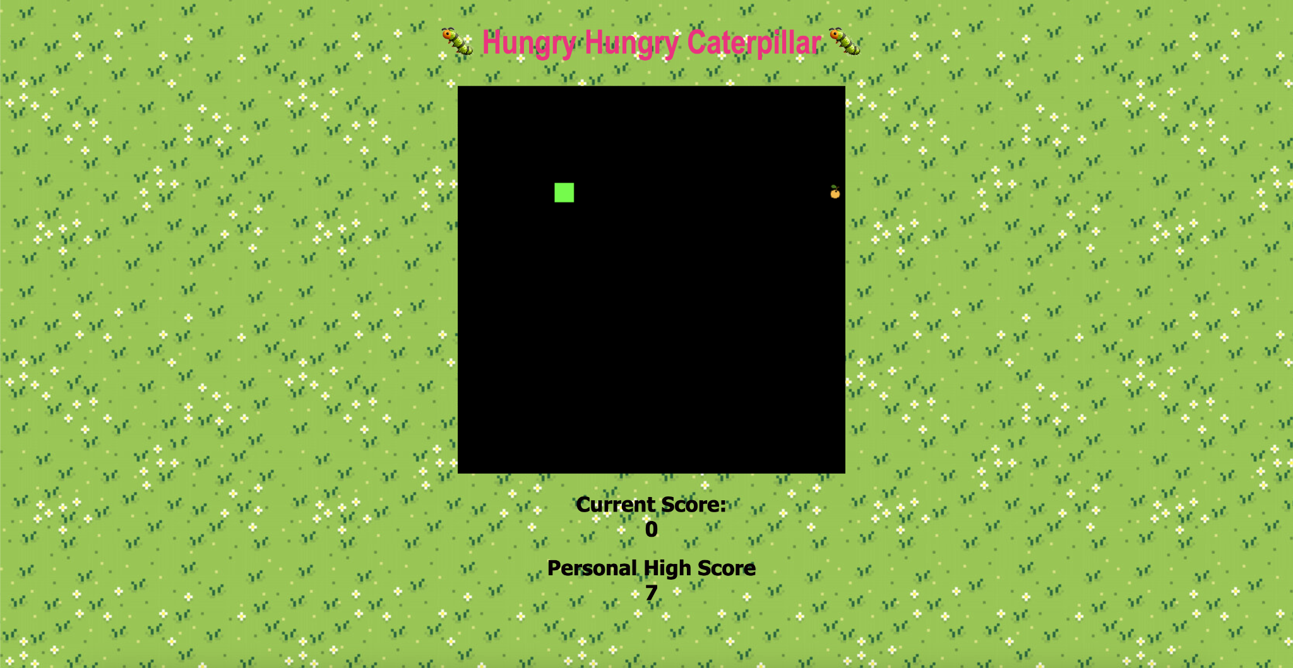

**End of Game Message stating game is over, resets game when you press ok**

